**1.Write a program in C to write multiple lines in a text file.**

#include<stdio.h>

int main()

{

FILE *fptr;

int i,n;

char str[100];

char fname[20]="multiple.txt";

char str1;

printf("Enter the number of lines to be written: ");

scanf("%d", &n);

printf("\nThe lines are:\n");

fptr=fopen(fname,"w");

for(i=0;i<n+1;i++)

{

fgets(str, sizeof str, stdin);

fputs(str,fptr);

}

fclose(fptr);

printf("\n");

//to read the file

fptr=fopen(fname,"r");

printf("The contents of file is\n");

str1=fgetc(fptr);

while(str1!=EOF)

{

printf("%c",str1);

str1=fgetc(fptr);

}

printf("\n");

fclose(fptr);

return 0;

}

**Output:**

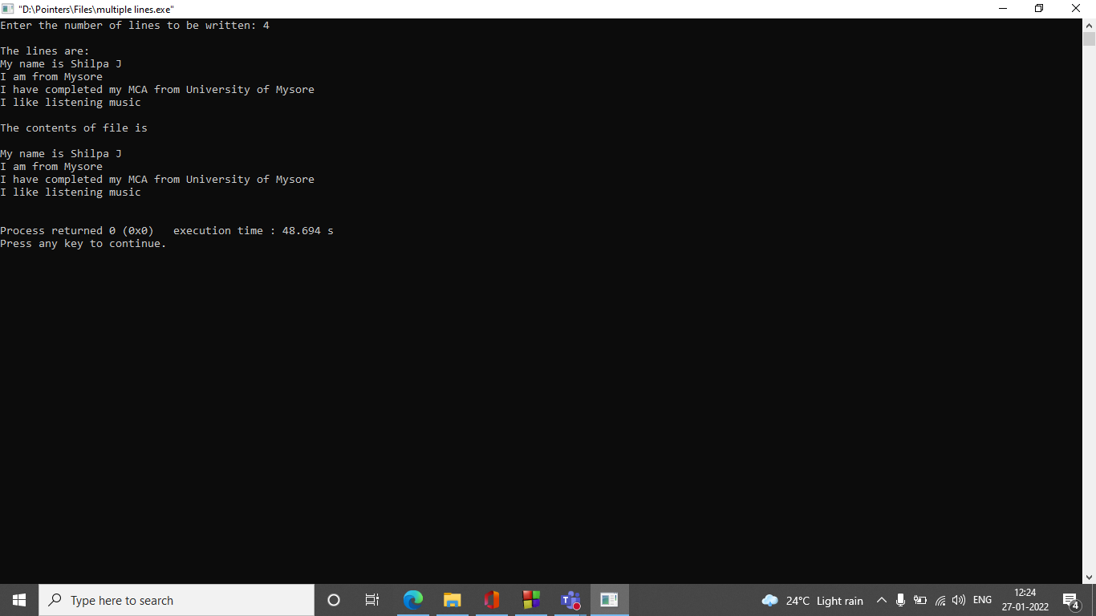

**2.Write a program in C to count a number of words and characters in a file.**

#include<stdio.h>

#include<stdlib.h>

int main()

{

FILE *fptr;

char ch;

int word=1,character=1;

char fname[20];

printf("Enter the file name to be entered: ");

scanf("%s",fname);

fptr=fopen(fname,"r");

if(fptr==NULL)

{

printf("File does not exist or cannot be opened.");

}

else

{

ch=fgetc(fptr);

printf("the content of file is\n");

while(ch!=EOF)

{

printf("%c",ch);

if(ch==' ' || ch=='\n')

{

word++;

}

else

{

character++;

}

ch=fgetc(fptr);

}

printf("\nThe number of words in the file are: %d\n",word-2);

printf("\nThe number of characters in the file are: %d\n",character-1);

}

return 0;

}

**Output:**

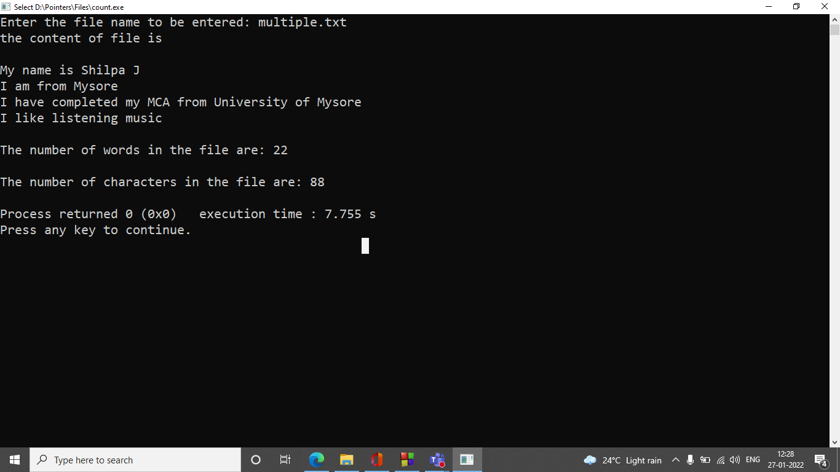

**3.Write a program in C to remove a file from the disk.**

#include<stdio.h>

void main()

{

int status;

char fname[20];

printf("Remove a file from the disk\n");

printf("\n");

printf("Input the name of file to be removed: ");

scanf("%s",fname);

status=remove(fname);

if (status==0)

{

printf("\nFile removed successfully\n");

}

else

{

printf("\nUnable to remove the file\n");

}

}

**Output:**

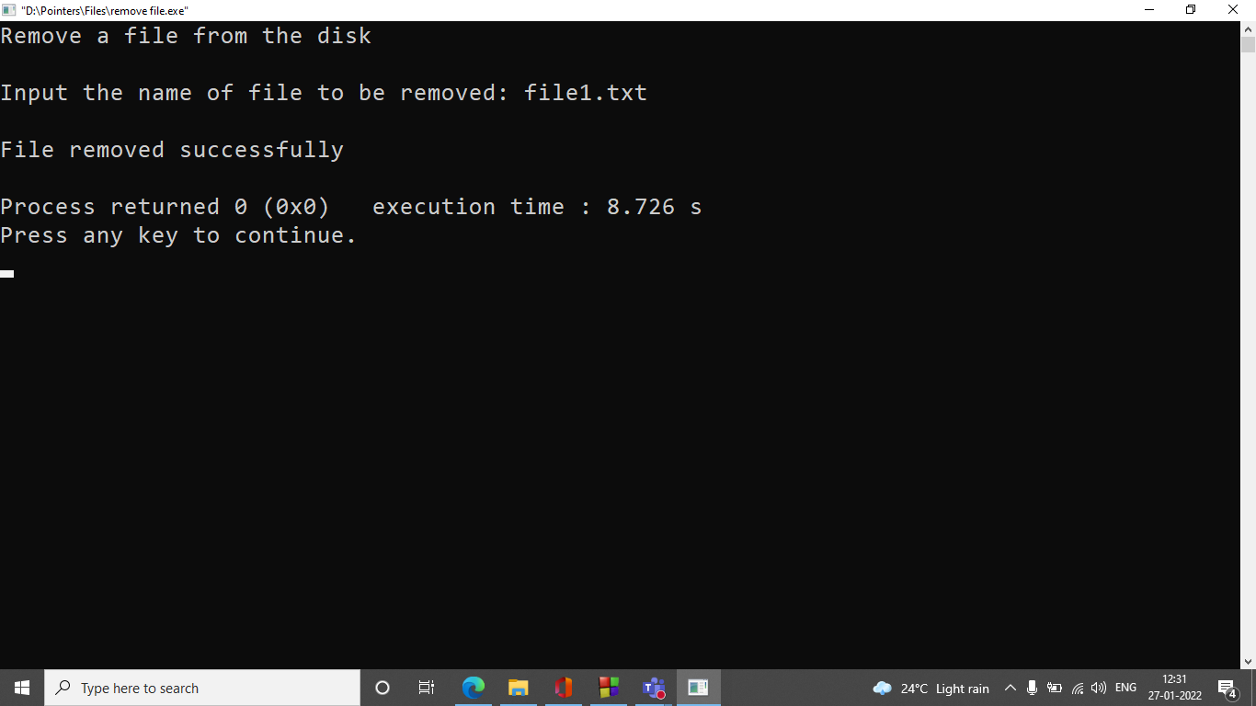

**4.Write a program in C to create and store information in a text file**

#include<stdio.h>

struct employee

{

int id;

char name[50];

float salary;

char temp;

};

int main()

{

struct employee e[60];

int i;

FILE *fp;

fp = fopen("employee.txt","w");

if(fp == NULL)

{

printf("Error in opening file\n");

exit(1);

}

for(i=0;i<2;i++)

{

printf("Enter details of employee %d\n\n", i+1);

printf("employee id:");

scanf("%d",&e[i].id);

scanf("%c",&e[i].temp);

printf("employee name:");

gets(e[i].name);

printf("employee salary:");

scanf("%f",&e[i].salary);

fwrite(&e[i],sizeof(e[i]),1,fp);

printf("\n");

}

fclose(fp);

//open to read the file

fp = fopen("employee.txt","r");

for(i=0;i<2;i++)

{

printf("\n\ndetails of %d employee are\n",i+1);

fread(&e[i], sizeof(e[i]),1,fp);

printf("employee id=%d\n",e[i].id);

printf("employee name=%s\n",e[i].name);

printf("employee salary=%f\n",e[i].salary);

}

fclose(fp);

}

**Output:**

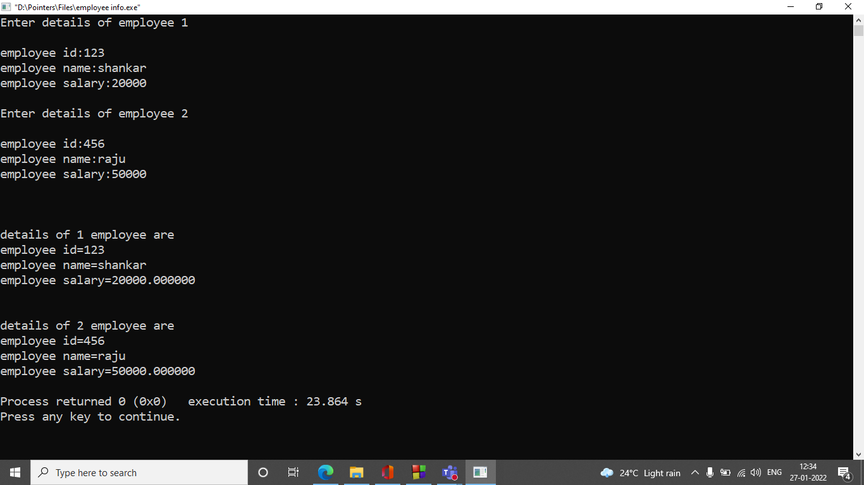

**5.Write a program in C to merge two files and write it in a new file.**

#include<stdio.h>

#include<stdlib.h>

int main()

{

//open the file 1 and file 2 to read

FILE *fp1=fopen("file1.txt","r");

FILE *fp2=fopen("file2.txt","r");

//open file 3 to merge

FILE *fp3=fopen("file3.txt","w");

char ch;

if(fp1 == NULL || fp2 == NULL || fp3 == NULL)

{

puts("could not open files");

exit(0);

}

//copy the content of file 1 to file 3

while((ch=fgetc(fp1))!=EOF)

fputc(ch,fp3);

//copy the content of file 2 to file 3

while((ch=fgetc(fp2))!=EOF)

fputc(ch,fp3);

printf("successfully merged!...");

fclose(fp1);

fclose(fp2);

fclose(fp3);

return 0;

}

**Output:**

